**Fold4 FRCNN 0.6 validation**

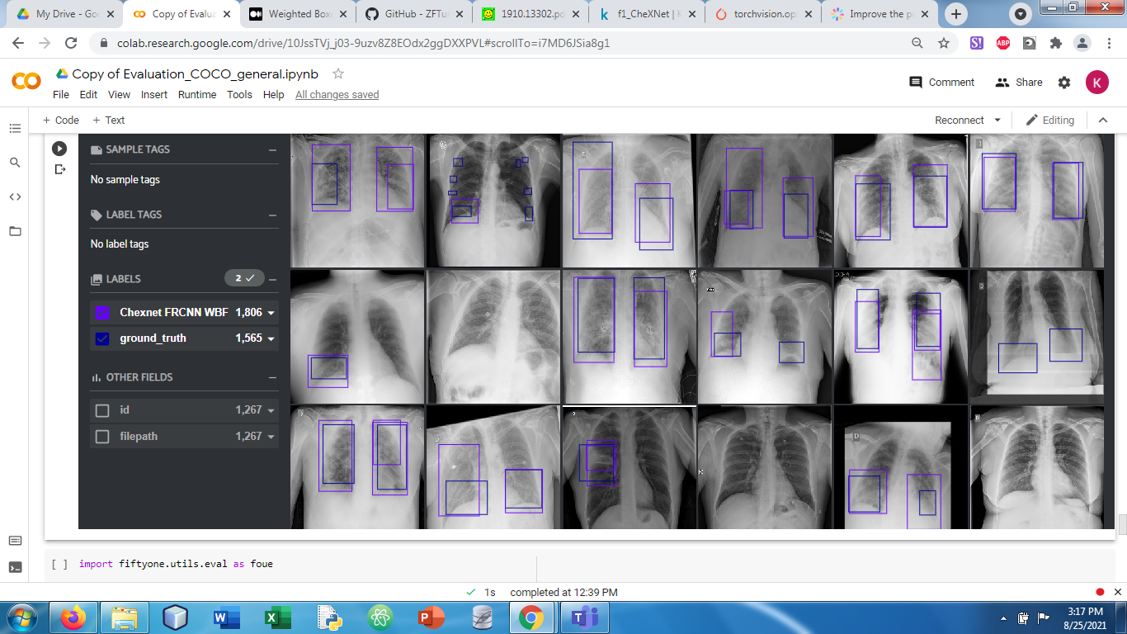

**Sample Submission:**

Private set: 0.093

Public set: 0.104

**Faster RCNN**

**Fold 1**

* Highest val AP: 0.4989, epoch 24
* Lowest val loss: 0.2241, epoch 3
* Total epochs: 29
* RSNA mAP: 0.23601408324357928
* SIIM Private: 0.268
* SIIM Public: 0.266

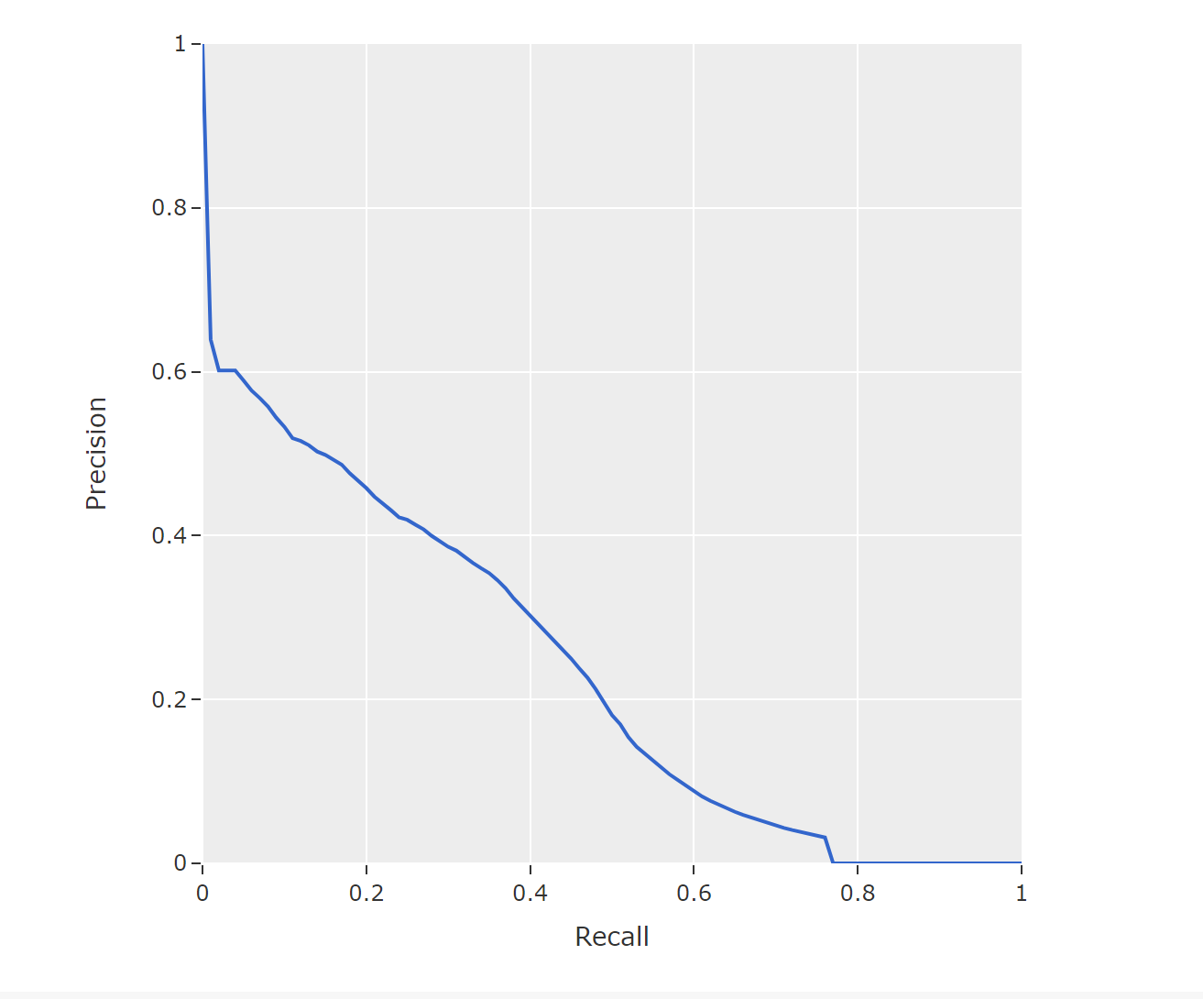

**Fold 2**

* Highest val AP: 0.5044, epoch 14
* Lowest val loss: 0.2232, epoch 17
* Total epochs: 29
* RSNA mAP: 0.23492006002190685
* SIIM Private: 0.269
* SIIM Public: 0.267
* 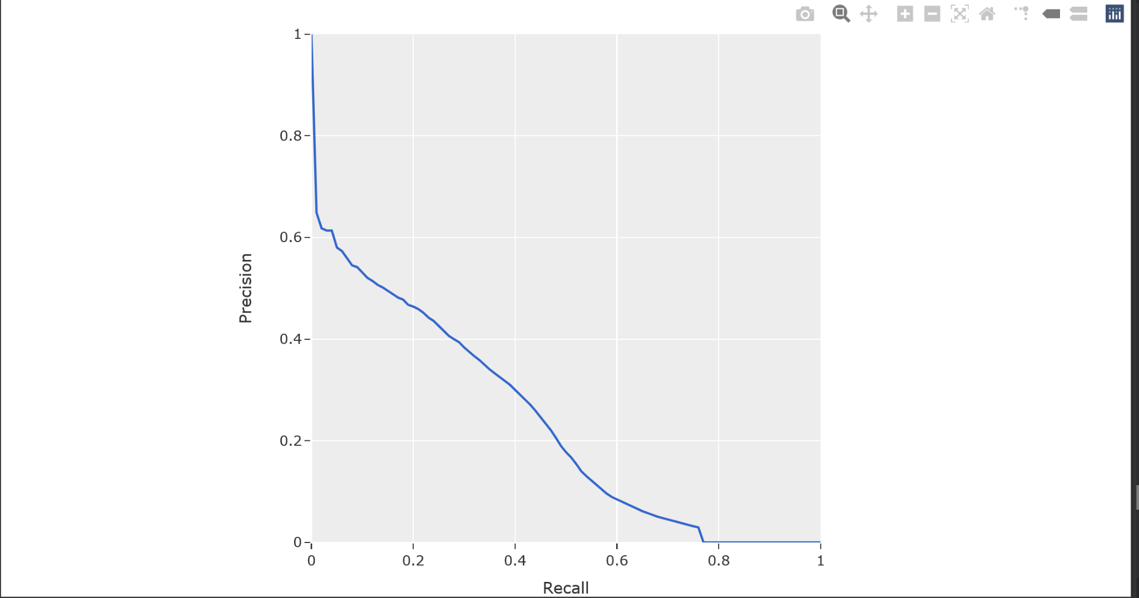

**Fold 3**

* Highest val AP: 0.5354, epoch 29
* Lowest val loss: 0.213, epoch 15
* Total epochs: 44
* RSNA mAP: 0.2325281437250957
* SIIM Private: 0.267
* SIIM Public: 0.267
* 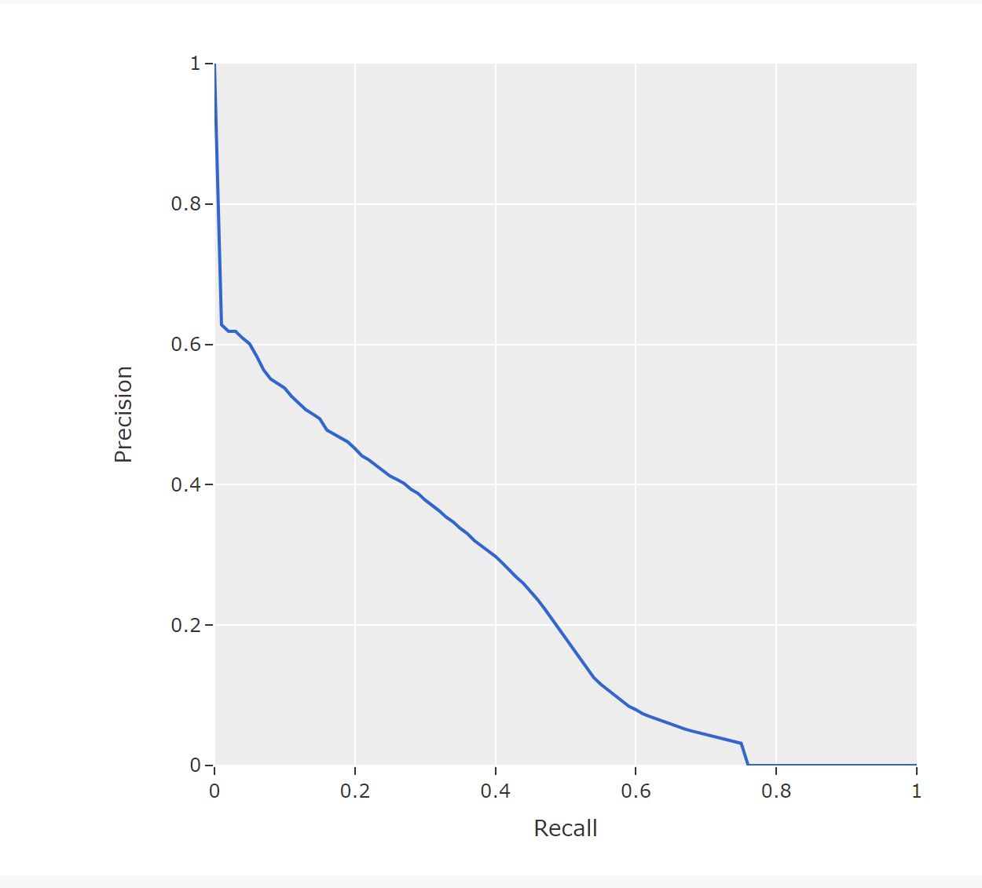

**Fold 4**

* Highest val AP: 0.484, epoch 14
* Lowest val loss: 0.2184, epoch 12
* Total epochs: 22
* SIIM Private: 0.269
* SIIM Public: 0.268
* RSNAscore: 0.23730863802029176

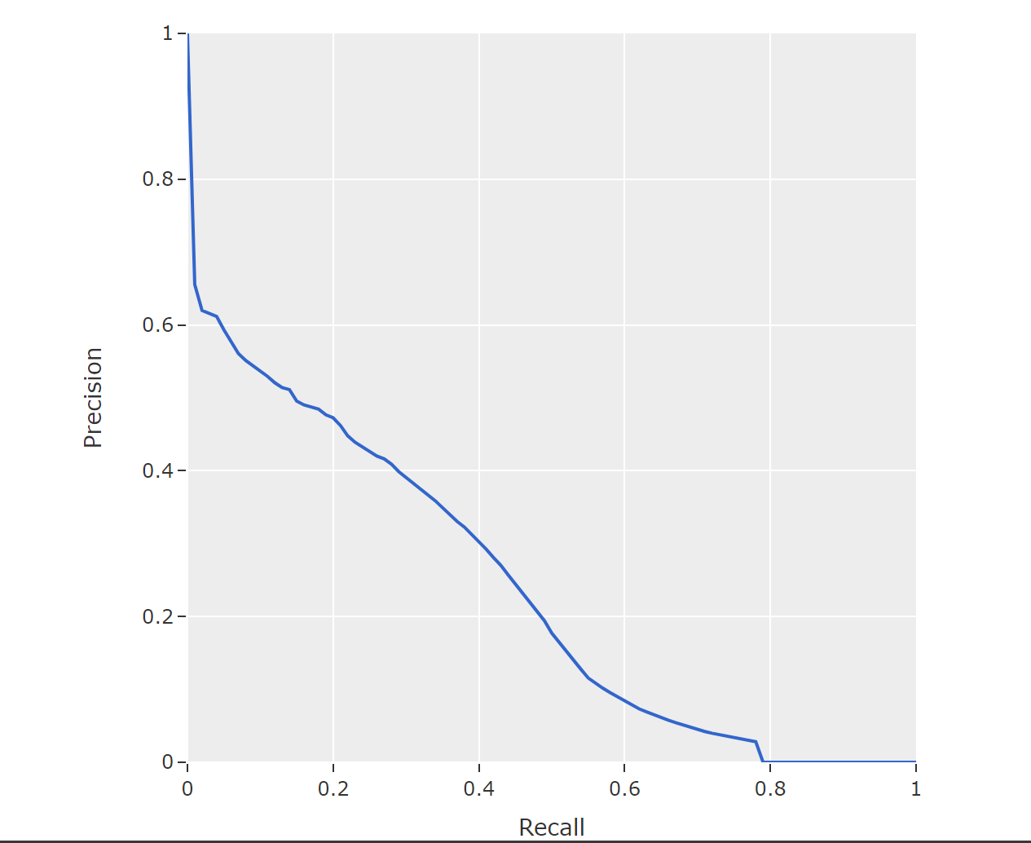

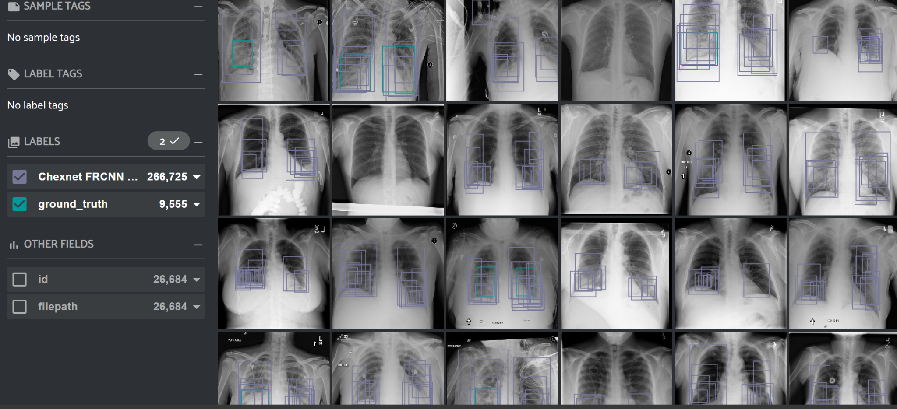

**Fold 5**

* Highest val AP: 0.5202, epoch 14
* Lowest val loss: 0.2151, epoch 15
* Total epochs: 36
* SIIM Private: 0.269
* SIIM Public: 0.270
* RSNA score: 0.23125050839544575
* 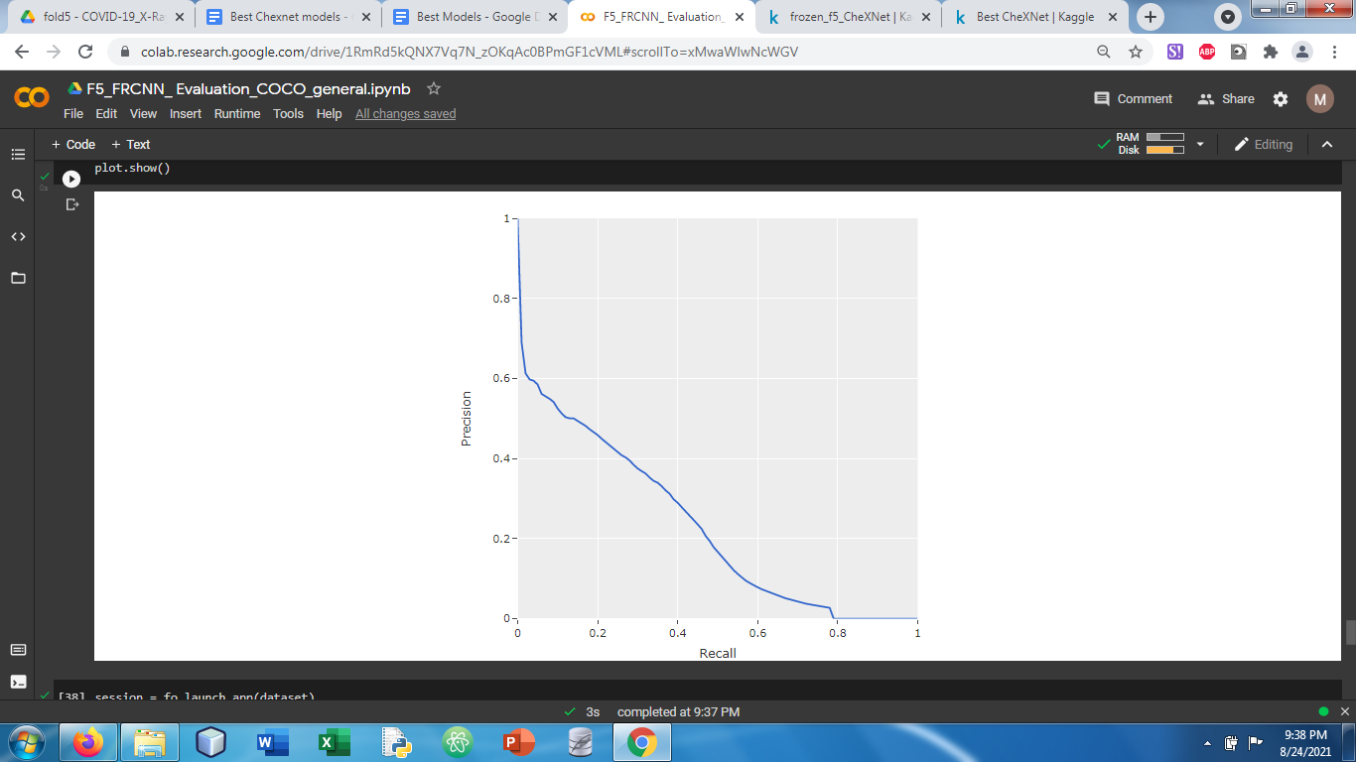
* 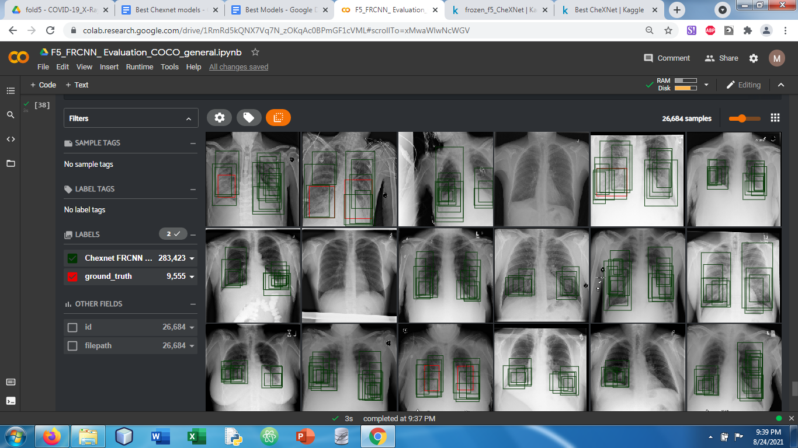
* 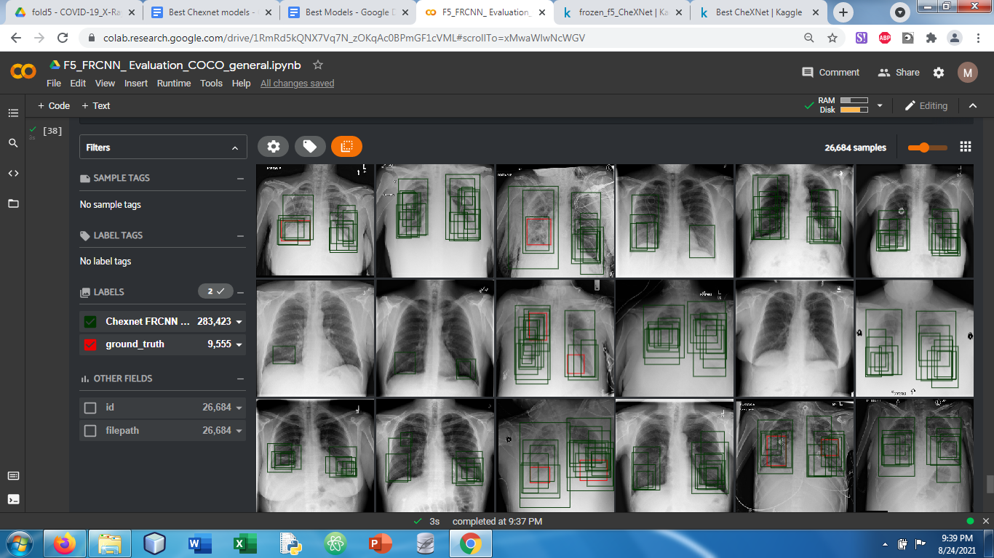

**ChexNet Faster RCNN**

**Fold 1**

* Highest val AP: 0.4791, epoch 20
* Lowest val loss: 0.1892, epoch 7
* Total epochs: 38
* SIIM Private: 0.264
* SIIM Public: 0.267
* RSNA score: 0.1956821079237777
* 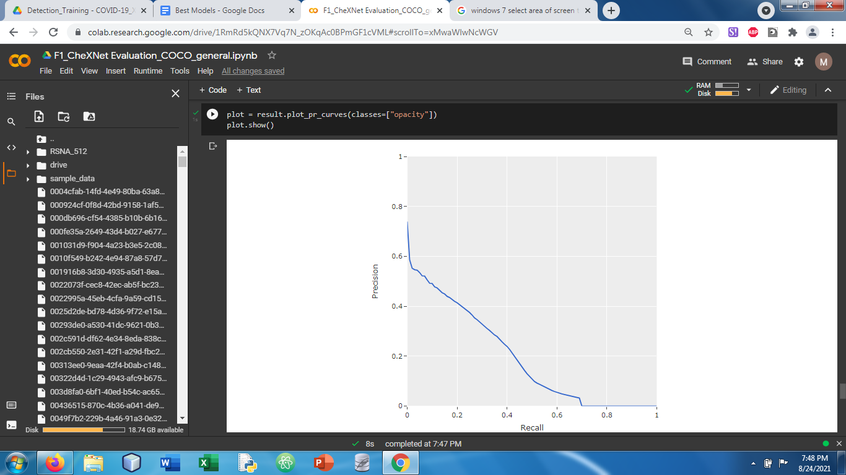
* 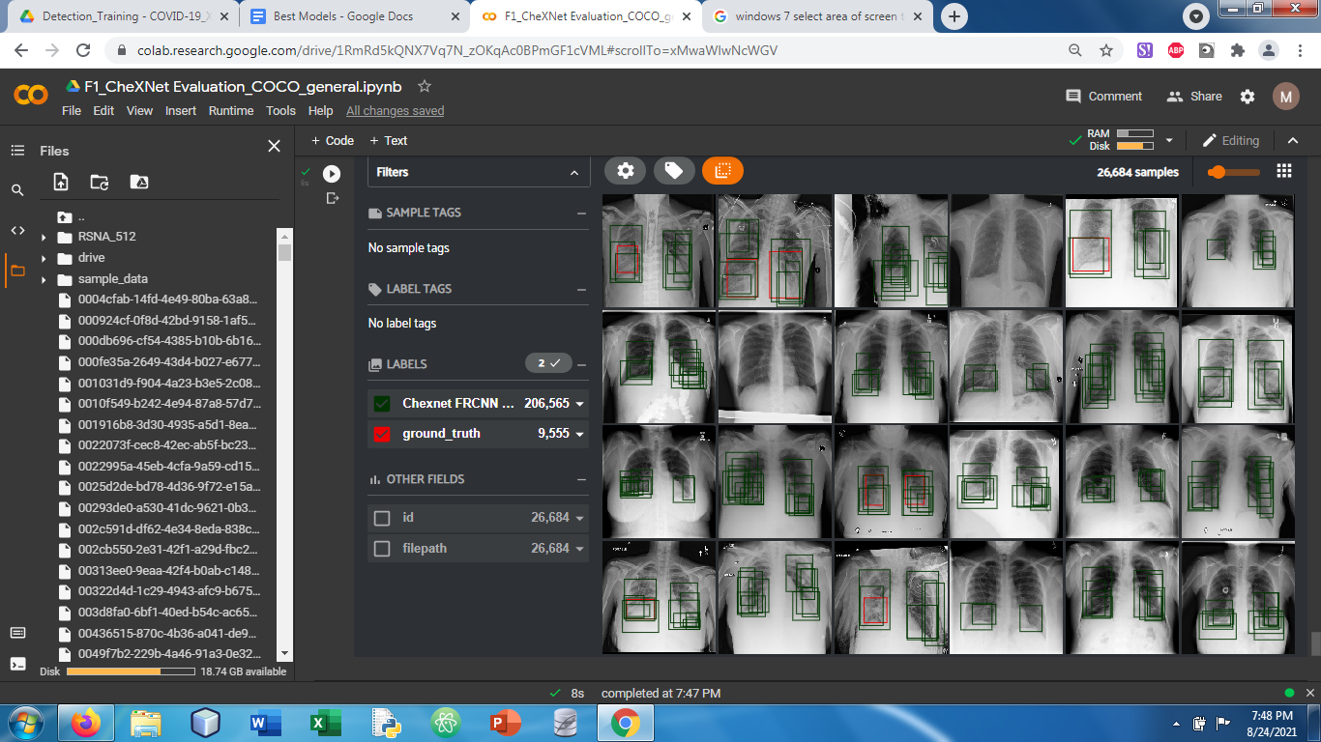
* 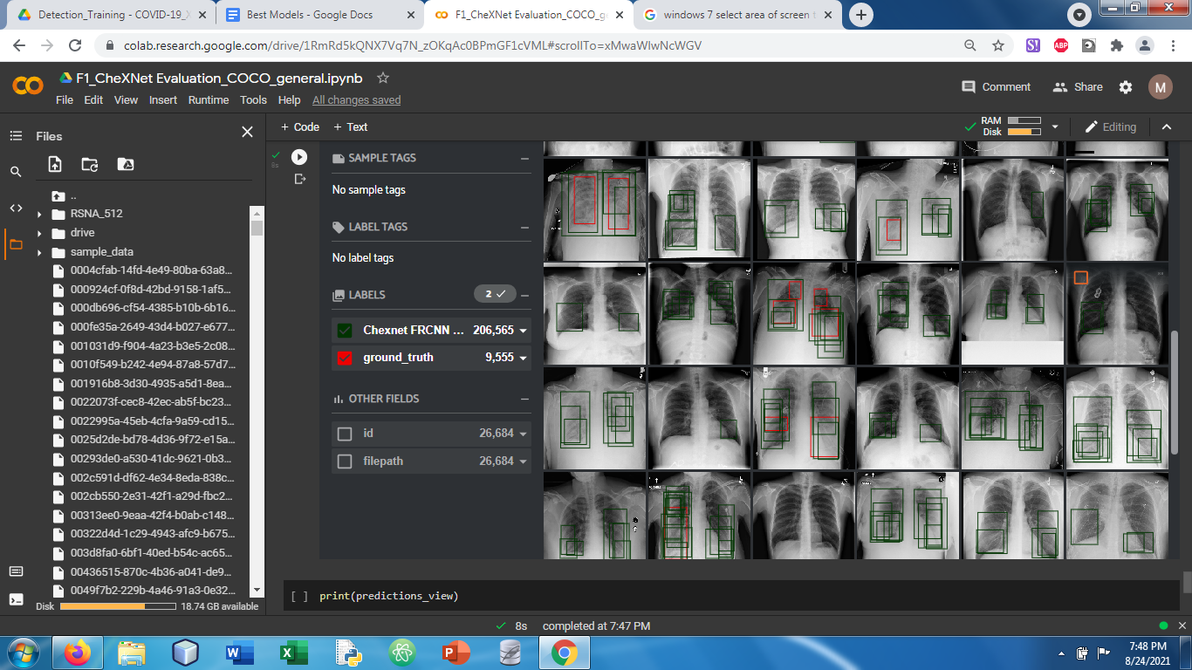

**Fold 2**

* Highest val AP: 0.5004, epoch 35
* Lowest val loss: 0.1873, epoch 39
* Total epochs: 59
* SIIM Private:0.265
* SIIM Public: 0.267
* RSNA set: 0.19787868385859098
* 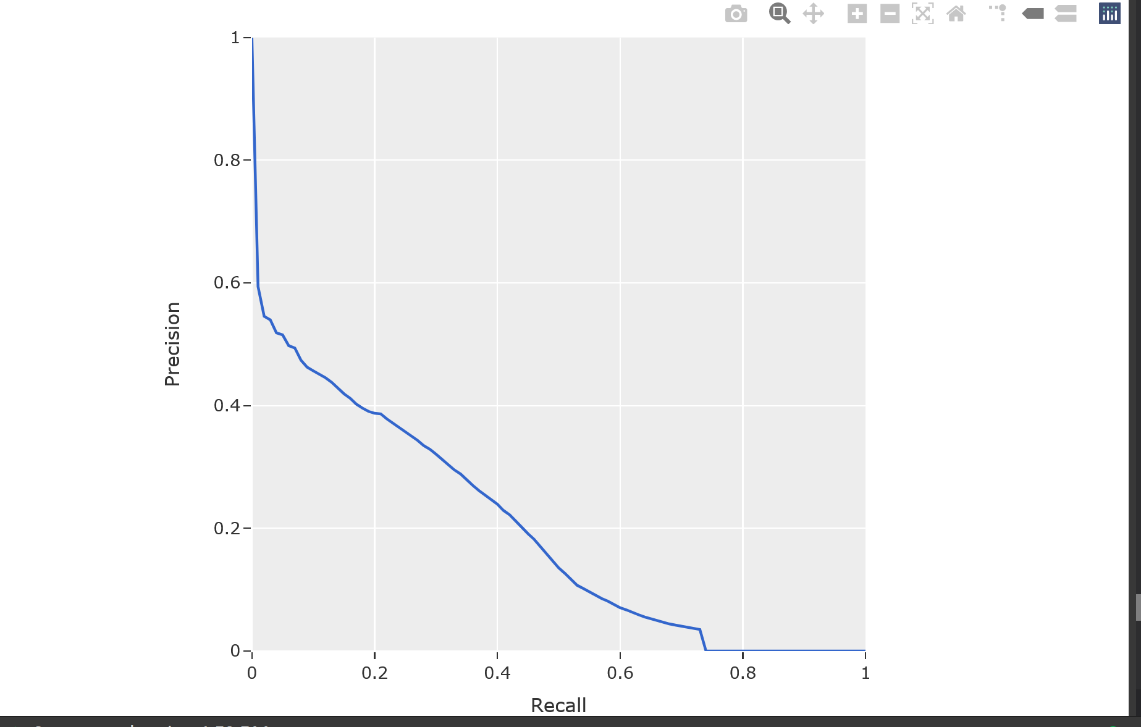

**Fold 3**

* Highest val AP: 0.5278, epoch 29
* Lowest val loss: 0.1845, epoch 7
* Total epochs: 44
* SIIM Private:0.267
* SIIM Public: 0.267
* RSNA score: 0.21638014829838

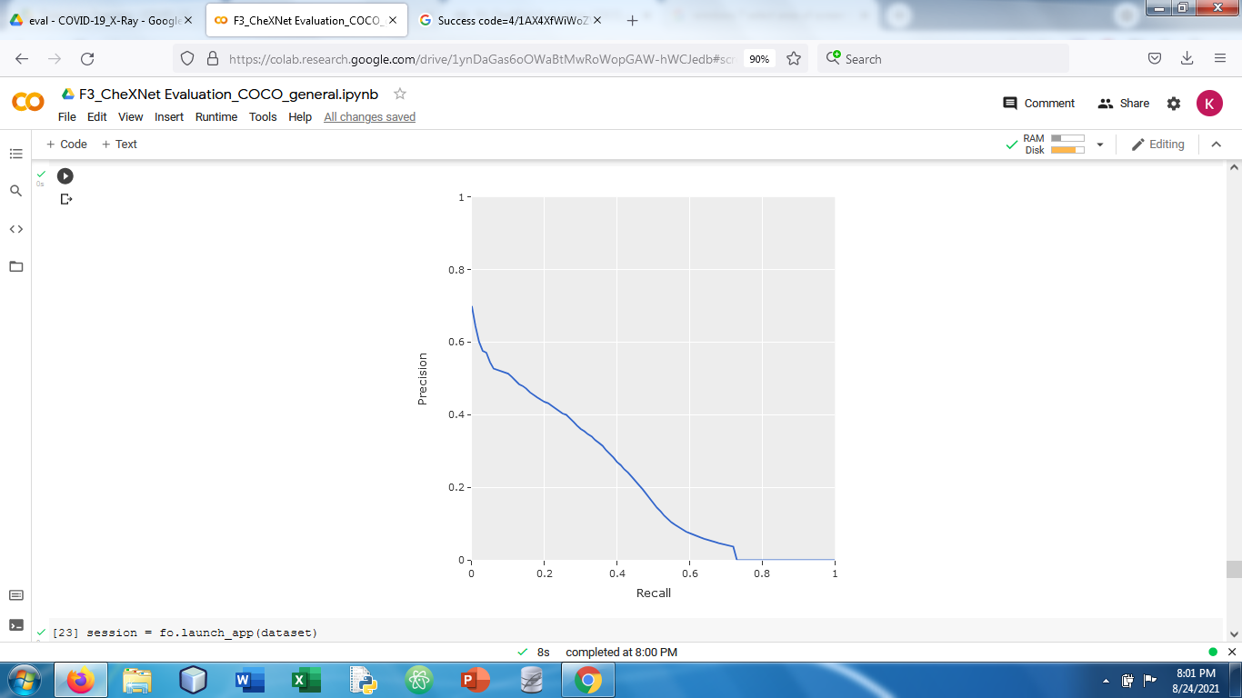

**Fold 4**

* Highest val AP: 0.4702 , epoch 27
* Lowest val loss: 0.1815, epoch 0
* Total epochs: 39
* SIIM Private: 0.268
* SIIM Public: 0.267
* RSNA Score: 0.22192114868568985
* 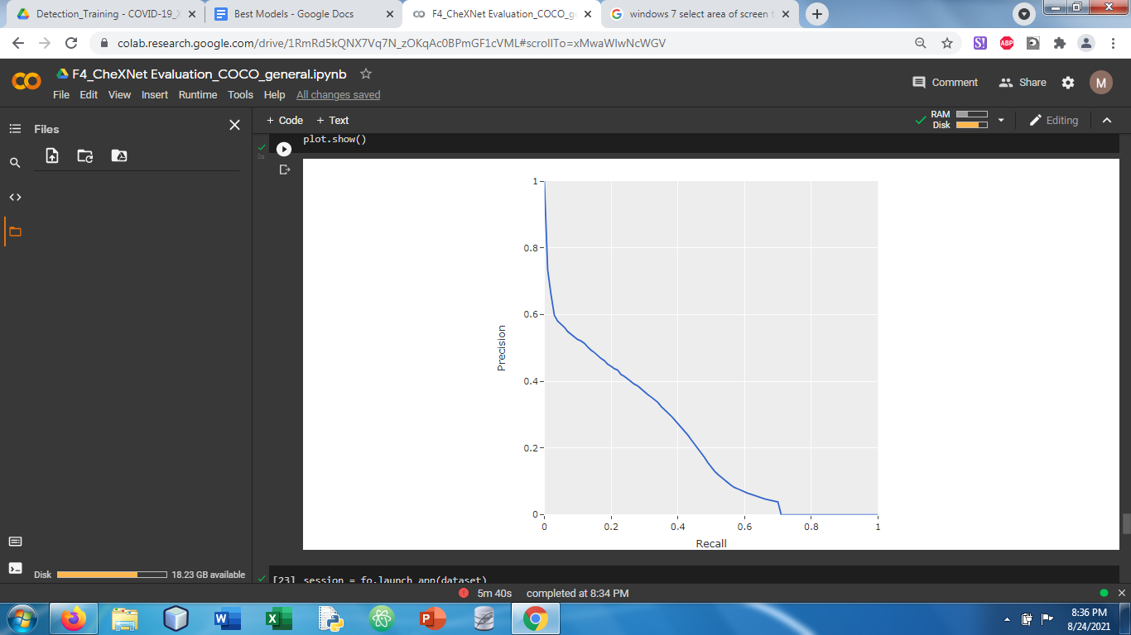
* 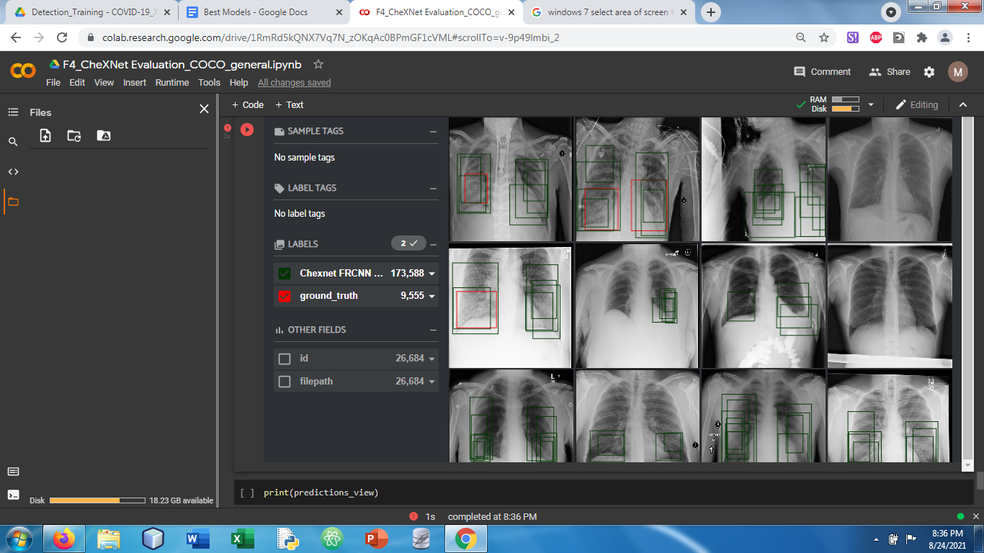
* 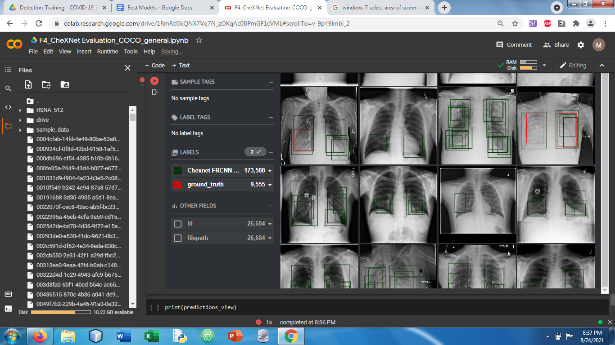
* 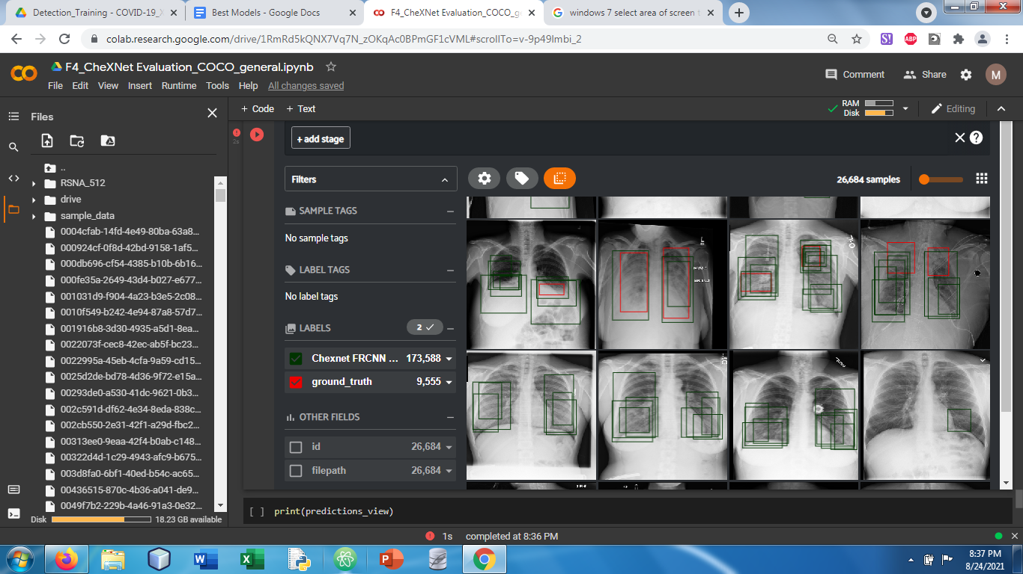

**Fold 5**

* Highest val AP: 0.5107, epoch 28
* Lowest val loss: 0.1793, epoch 8
* Total epochs: 36
* SIIM Private: 0.267
* SIIM Public: 0.267
* RSNA score: 0.23029594020845043
* 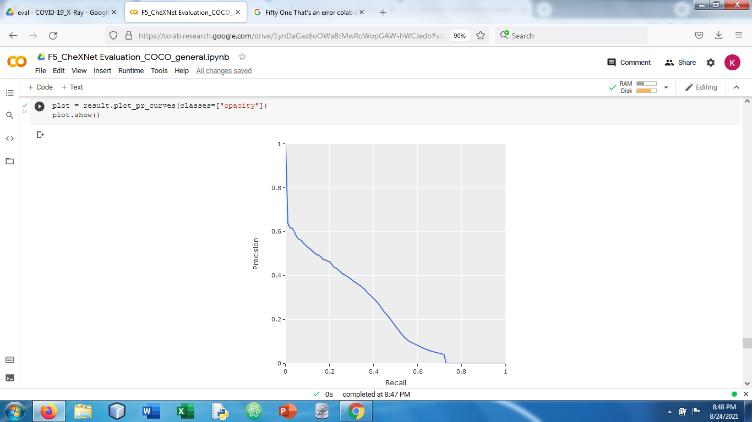

**Fold2 with all layers frozen:**

Siim private: 0.258

Siim public: 0.259

**Fold5 with all layers frozen:**

Siim private: 0.258

Siim public: 0.260